**Practical 1**

Aim: Study of basic elements of computer networking with details of networking devices.

Theory:

**Networking devices** are hardware components used to connect computers and other electronic devices together in a network. They help in **data transmission**, **network communication**, and **management**. Each device serves a specific role depending on the type and structure of the network.

Common network devices:

### **1. Hub**

A **hub** is a basic networking device that connects multiple computers in a LAN. It broadcasts incoming data to all connected devices, regardless of the destination, which increases network traffic and reduces efficiency. Hubs operate at the **physical layer (Layer 1)** of the OSI model and lack data filtering or traffic management.

### **2. Switch**

A **switch** is more advanced than a hub and connects multiple devices in a LAN. It uses **MAC addresses** to send data only to the intended device, improving efficiency and reducing traffic. Switches operate at the **data link layer (Layer 2)**.

### **3. Router**

A **router** connects different networks, like a home network to the internet. It uses **IP addresses** to find the best path for data. Routers work at the **network layer (Layer 3)** and also manage IP assignment and traffic.

### **4. Modem**

A **modem** (modulator-demodulator) converts **digital signals to analog** for transmission over telephone or cable lines and vice versa. It is essential for **internet access** through ISPs and is common in home networks.

### **5. Access Point (AP)**

An **access point (AP)** enables **wireless devices** to connect to a **wired network**. It provides Wi-Fi access by bridging wireless clients with Ethernet. APs are used to extend wireless coverage in homes and offices.

### **6. Repeater**

A **repeater** amplifies weak network signals to **extend their range**. It is useful in large areas where signal strength drops. Repeaters operate at the **physical layer (Layer 1)**.

### **7. Bridge**

A **bridge** connects two or more LAN segments using the same protocol. It filters traffic and reduces collisions, improving performance. Bridges work at the **data link layer (Layer 2)**.

## **Topology**

**Topology** in networking is the layout or arrangement of devices and connections in a network. It defines how data flows and how devices communicate. The choice of topology affects network performance, reliability, and scalability.

## **Types of Network Topology**

### **1. Bus Topology**

In a **bus topology**, all devices are connected to a single central cable called the **bus** or backbone. Data sent by one device travels along the bus in both directions and is received by all devices, but only the intended recipient processes the data. This topology is simple and cost-effective since it uses less cabling. However, if the main cable fails or is damaged, the entire network stops working. It is also difficult to troubleshoot, and performance degrades with increased traffic.

### **2. Star Topology**

In a **star topology**, each device is connected to a central device, such as a **hub** or **switch**. All communication between devices goes through this central node. It is easy to install and manage, and failures in one device do not affect others. However, if the central hub or switch fails, the whole network becomes inoperable. This topology is widely used in modern LANs because of its robustness and ease of troubleshooting.

### **3. Ring Topology**

A **ring topology** connects devices in a circular fashion, where each device has exactly two neighbors. Data travels in one direction (unidirectional) or both directions (in a dual ring). Each device acts as a repeater, passing the data along the ring. While ring topology provides equal access and can perform well under heavy load, the failure of any single device or cable breaks the network. It’s less common today but was used in technologies like Token Ring networks.

### **4. Mesh Topology**

In a **mesh topology**, every device is connected directly to every other device. This creates multiple paths for data to travel, ensuring high redundancy and reliability. If one link fails, data can be rerouted through other connections. Mesh networks can be **full mesh** (all devices interconnected) or **partial mesh** (some devices interconnected). While it offers excellent fault tolerance and robustness, it is costly and complex to implement due to the large number of cables and ports required.

### **5. Tree Topology**

A **tree topology** is a hierarchical combination of bus and star topologies. Groups of star-configured devices are connected to a main bus backbone. This allows for easy expansion and scalability by adding more devices to the branches. However, if the main bus backbone fails, large portions of the network become disconnected. Tree topology is commonly used in large networks where segmentation and expansion are needed.

### **6. Hybrid Topology**

A **hybrid topology** combines two or more different types of topologies, such as star-ring or star-bus. This allows a network to leverage the advantages of each topology type and tailor the design to specific needs, such as scalability, reliability, or cost efficiency. Hybrid topologies are flexible and scalable but tend to be more complex to design and manage.

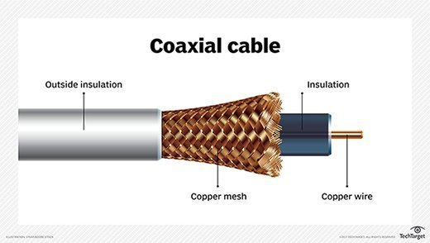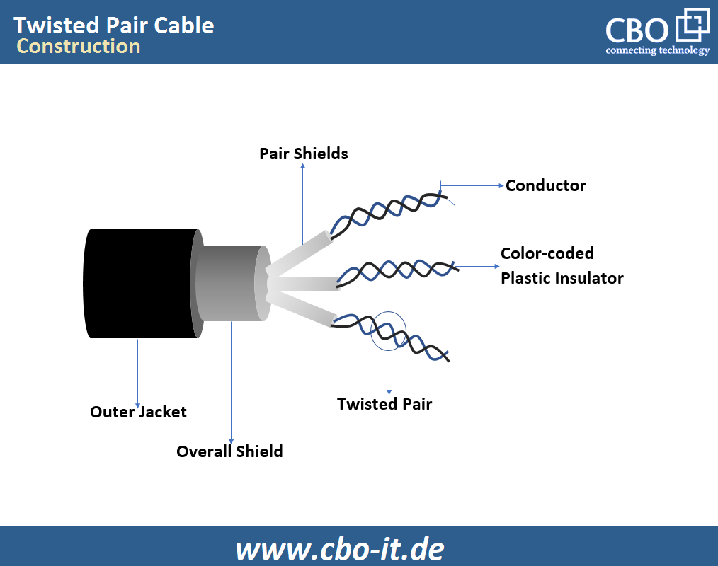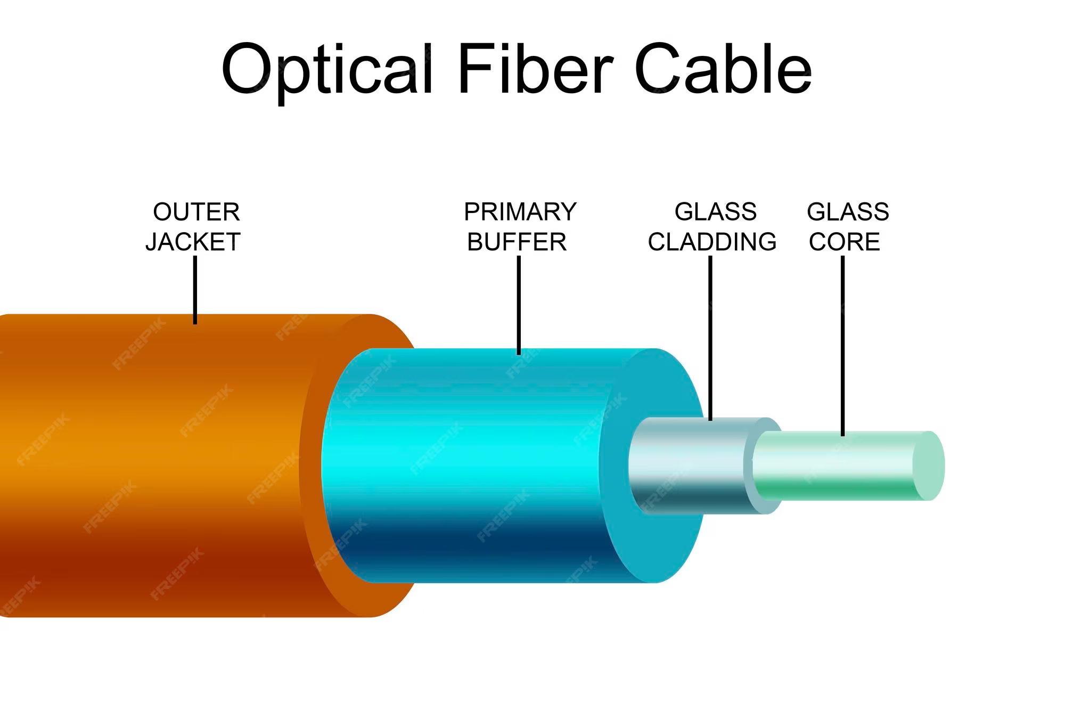

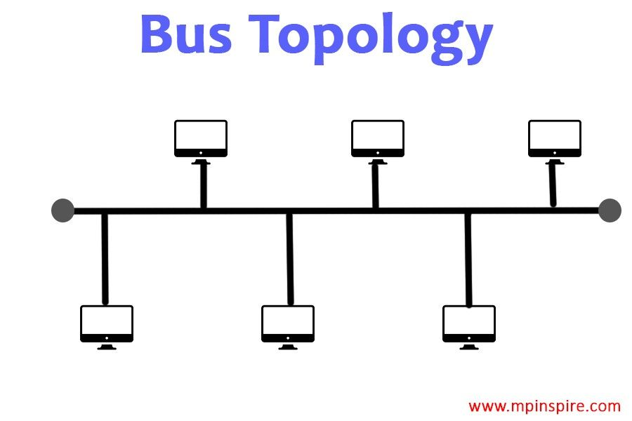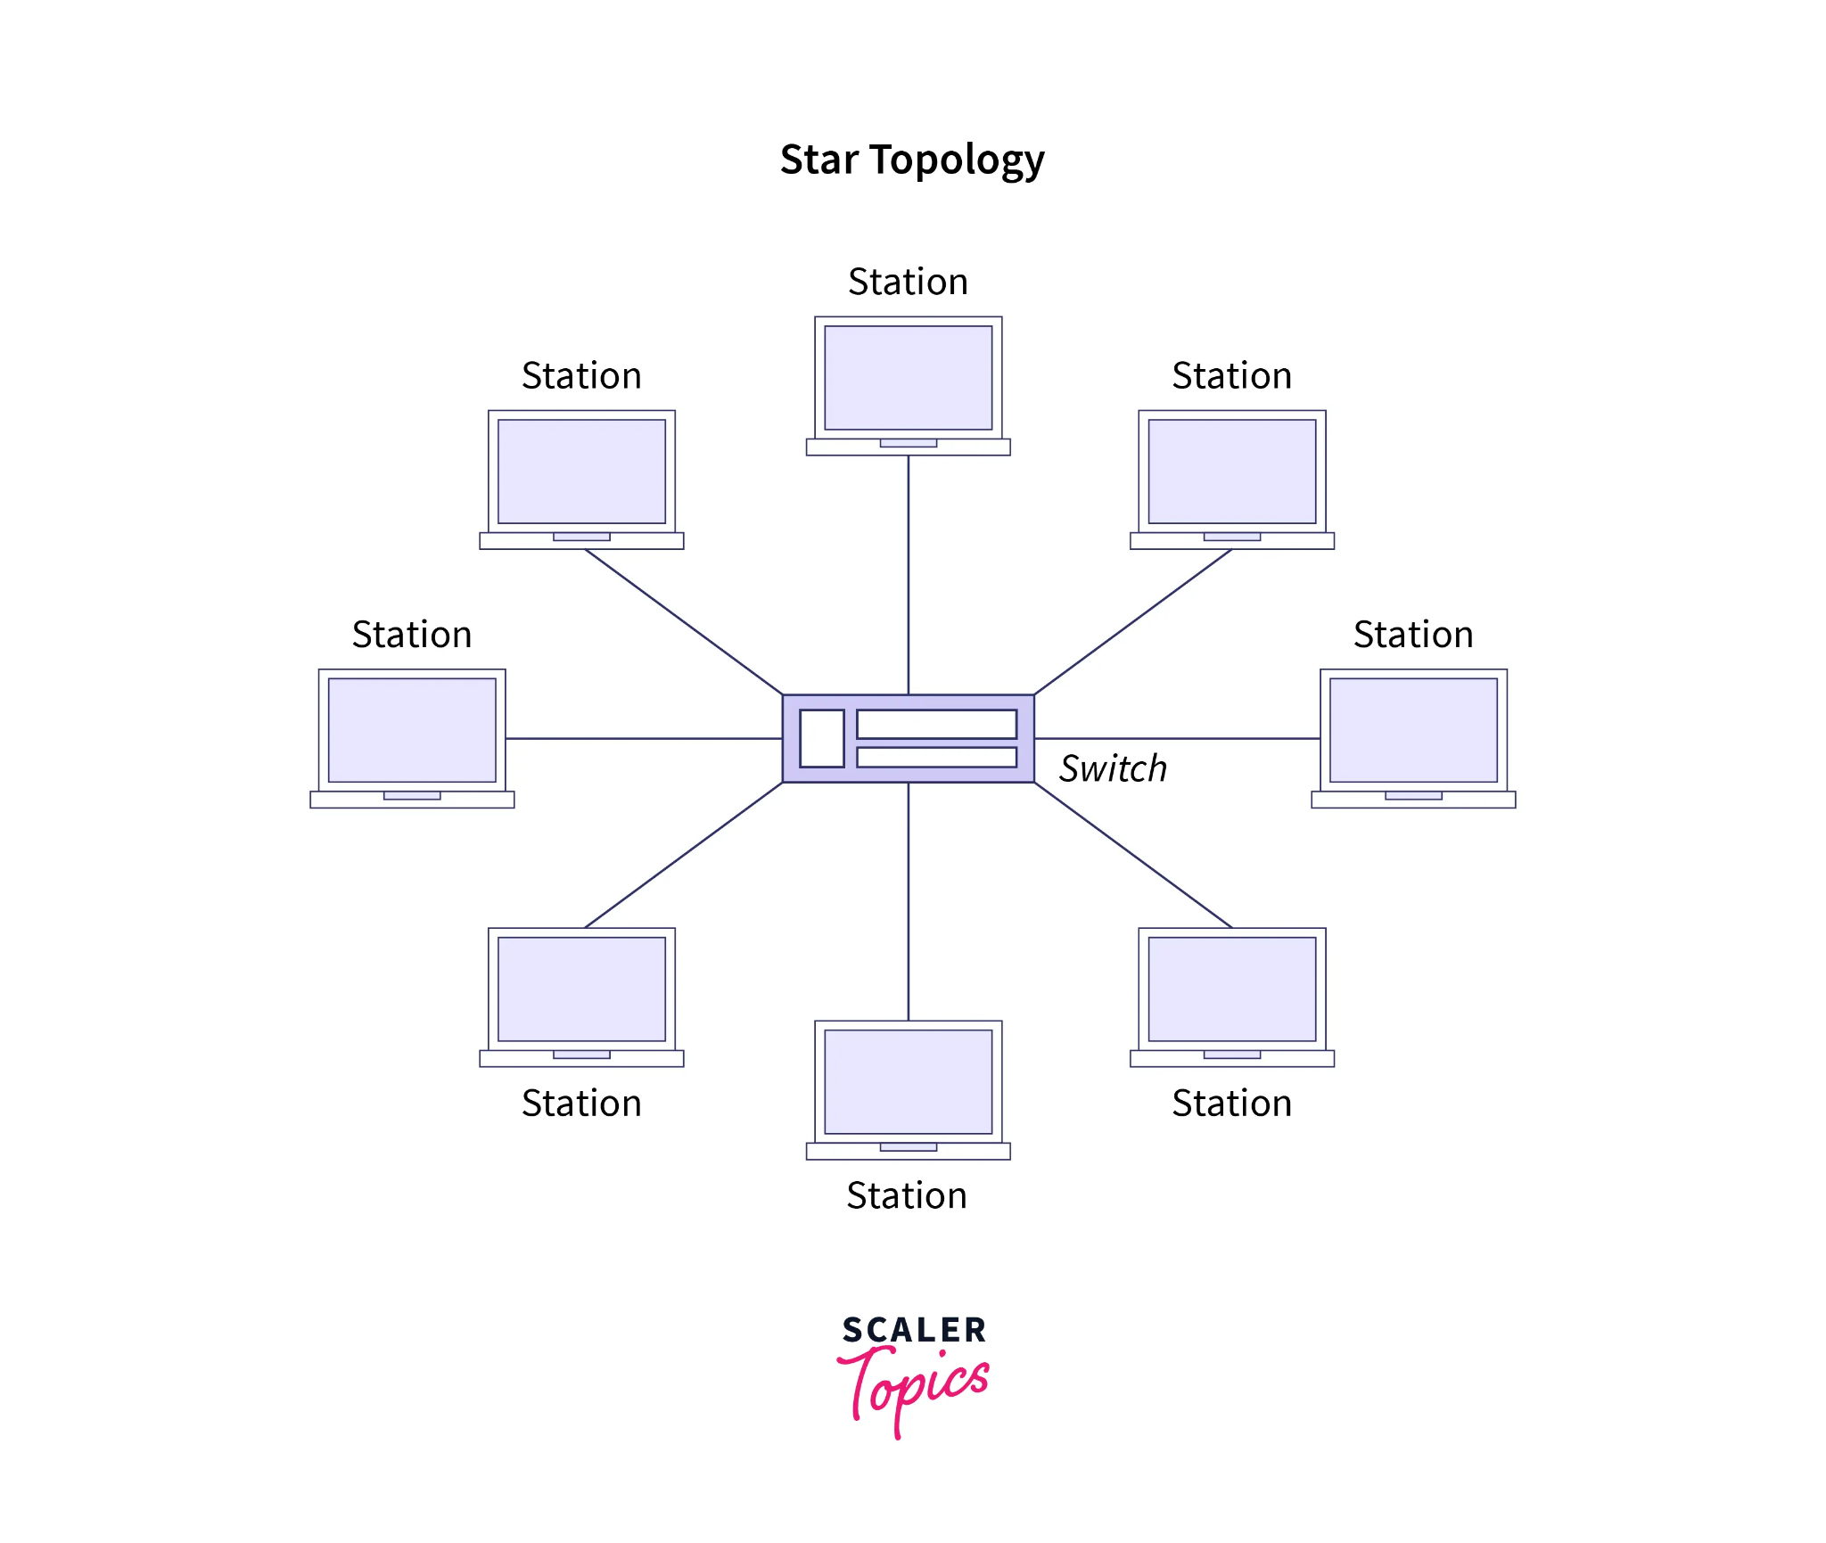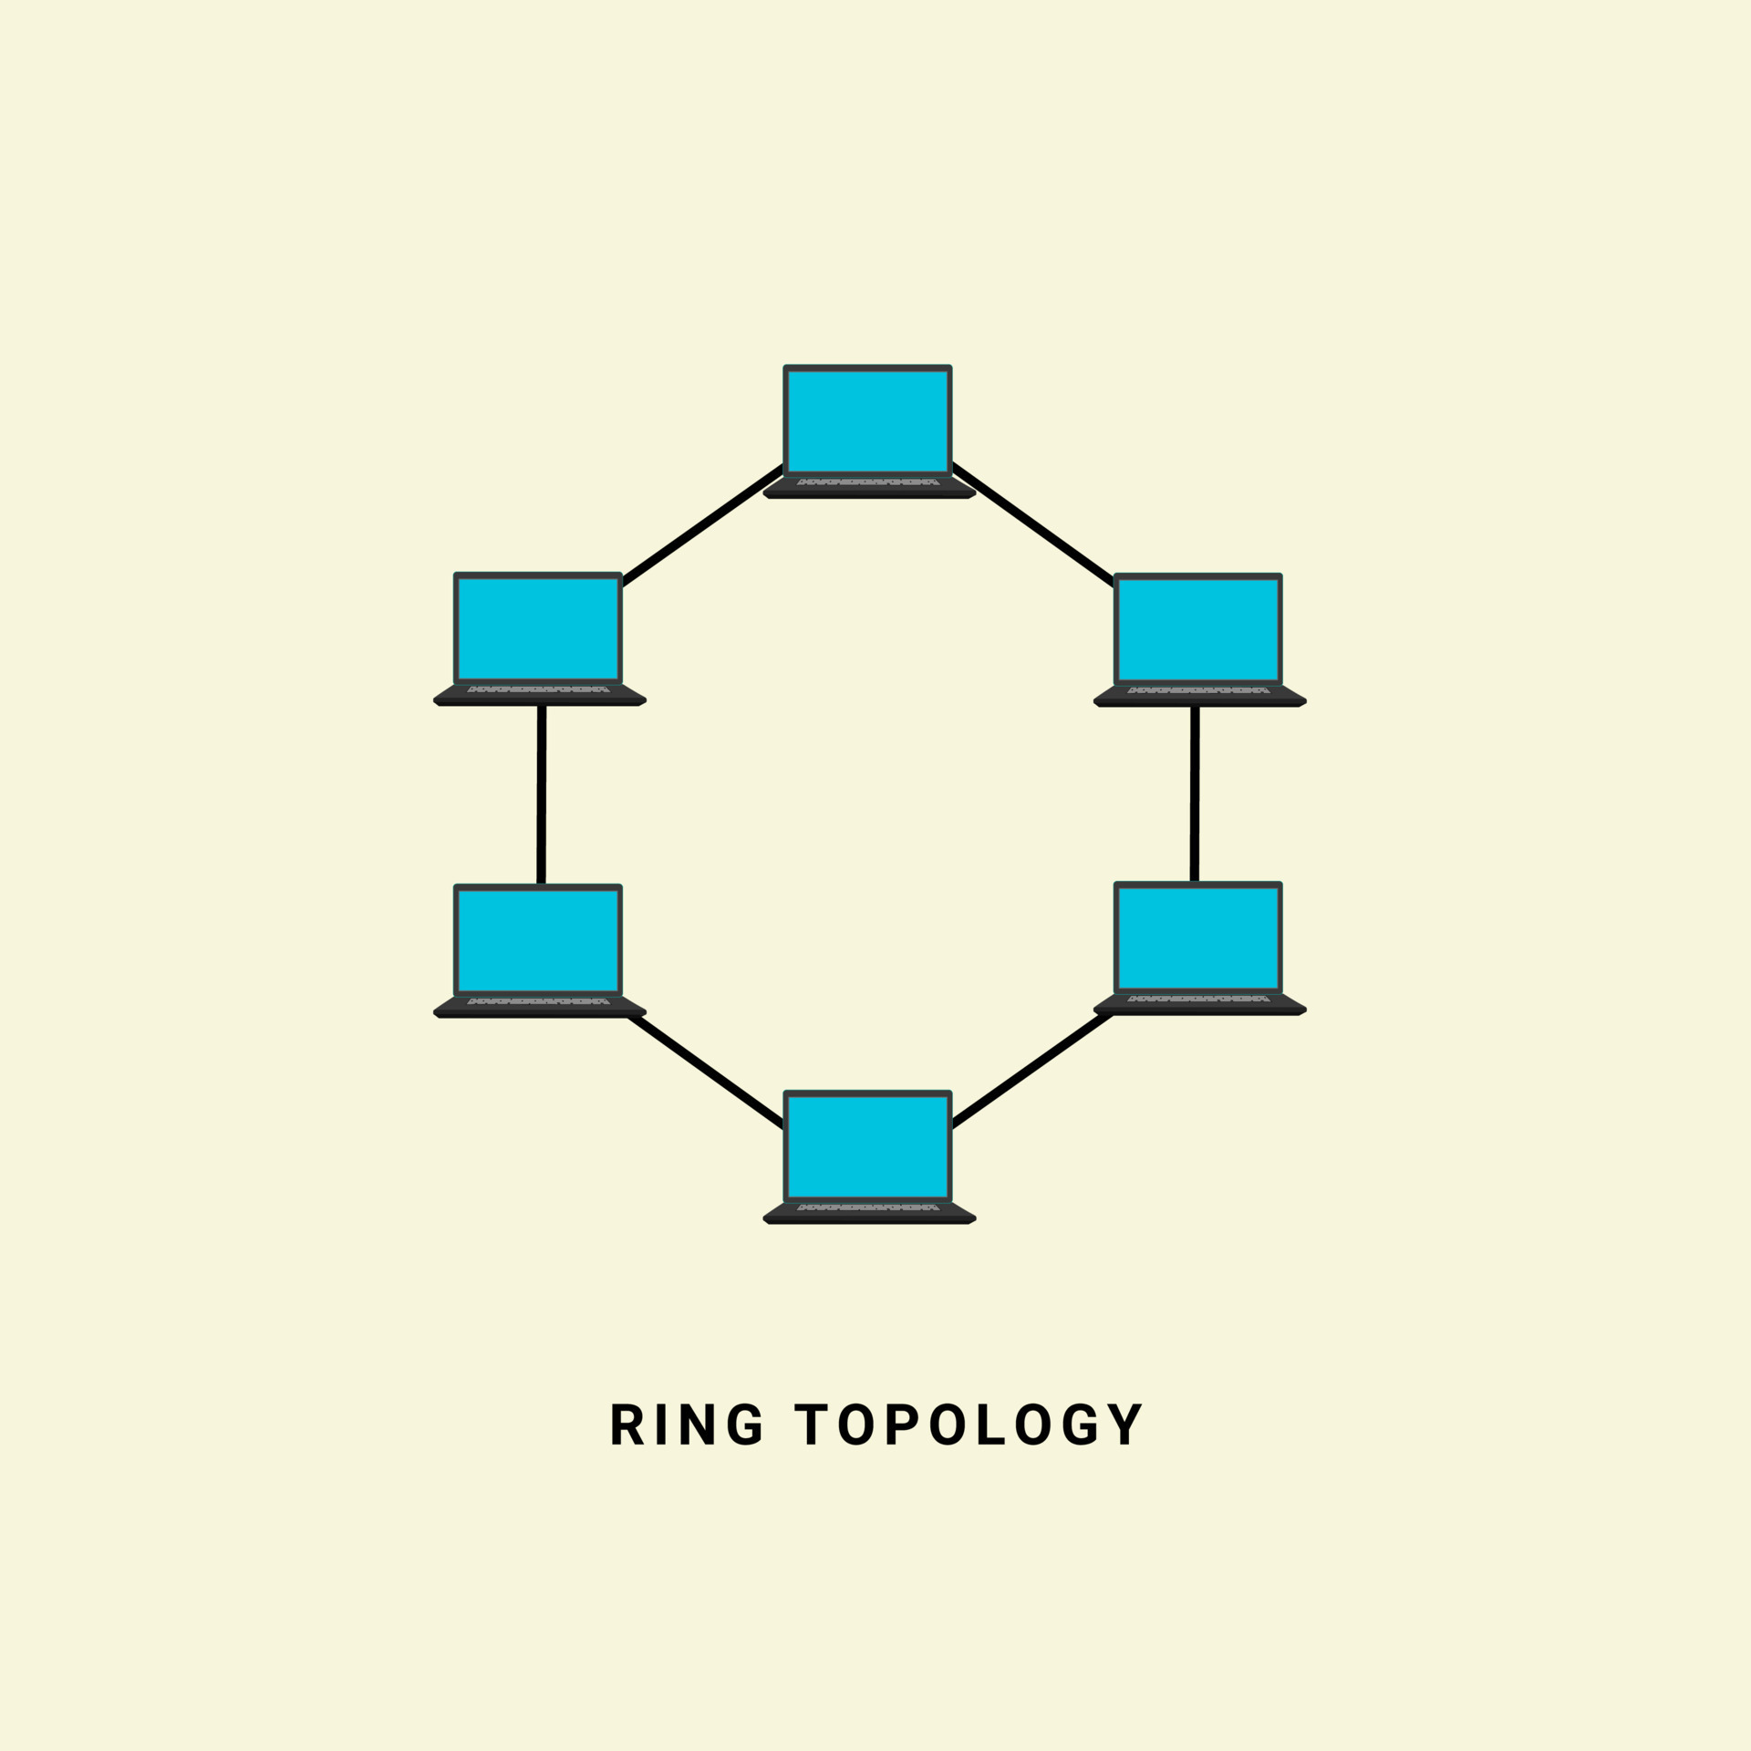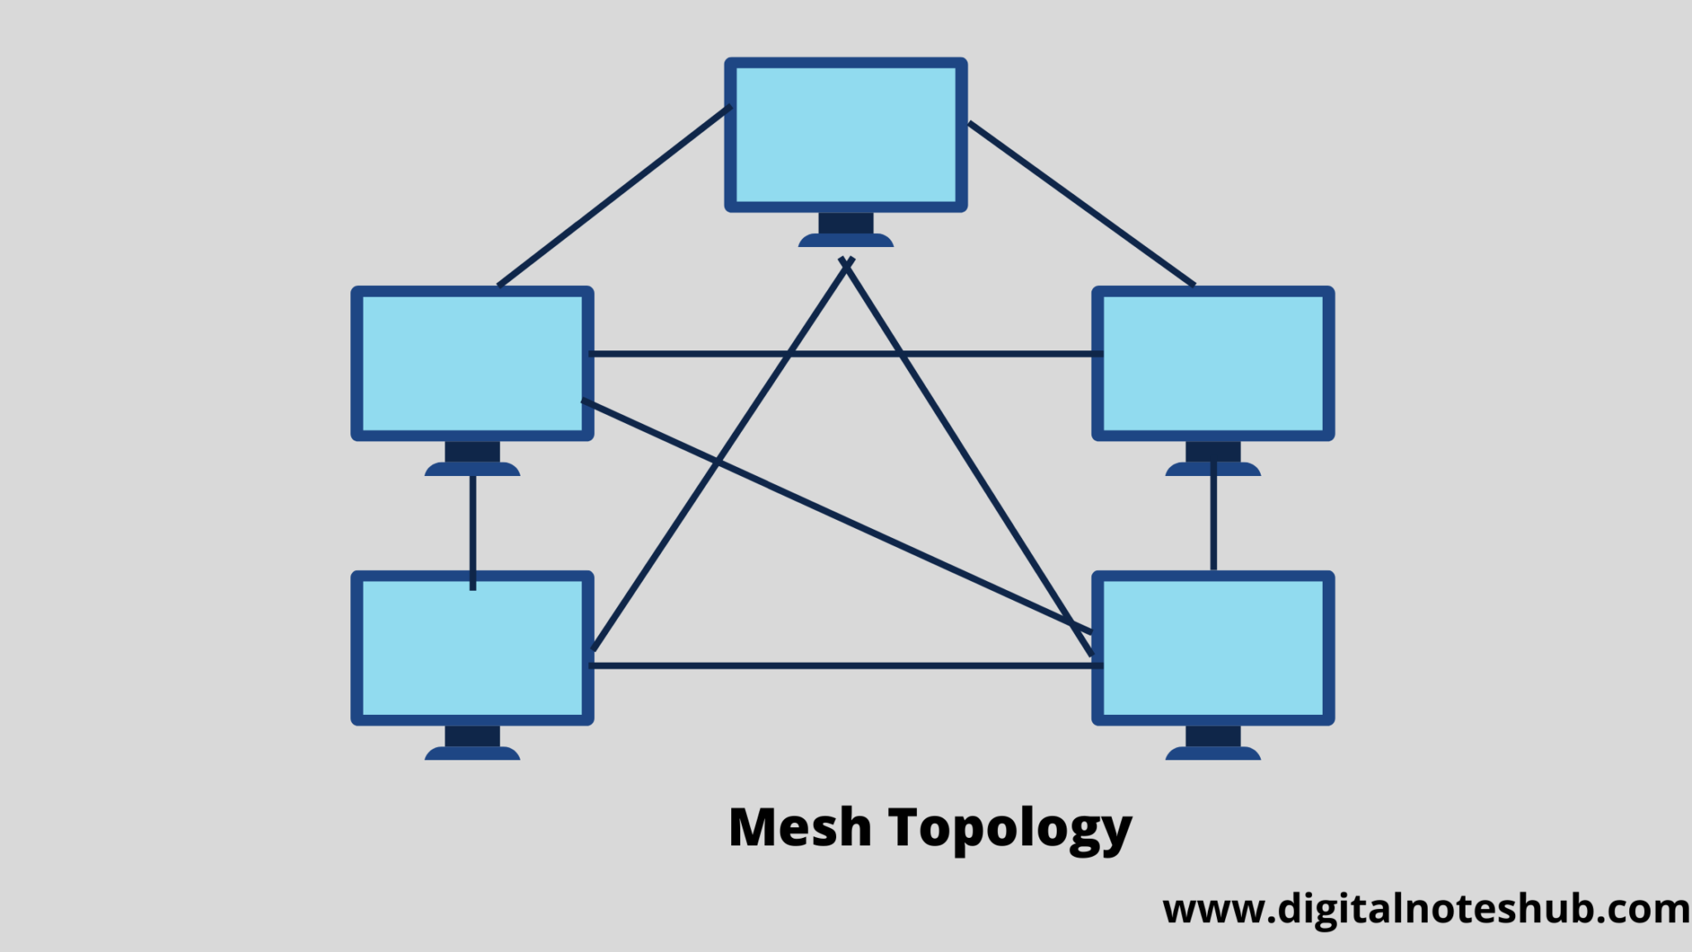

Conclusion:

Hence, studied basic elements of computer networking with details of networking devices.